NCCD CONFERENCE – MOUNT ST BENEDICT CENTRE, PENNANT HILLS
7-9 October 2015
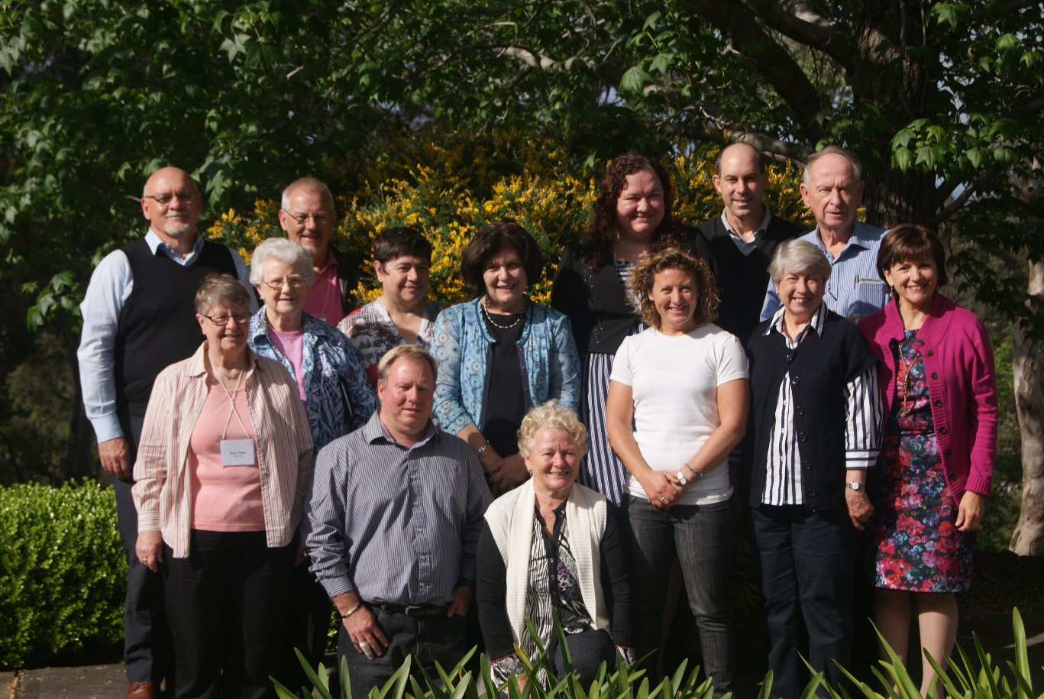

Conference delegates from the Dioceses of Cairns, Townsville, Rockhampton, Newcastle-Maitland, Broken Bay, Sydney, Wollongong, Armidale, Parramatta, Melbourne and Perth.

NCCD members from eleven dioceses gathered at Mount St Benedict Centre, Pennant Hills from 7-9 October 2015.
The Conference began with a prayer reflection on the theme Our Journey With God in Ministry, based on the call to follow Jesus and make disciples of others.
Members were then invited to share their varying diocesan stories and journeys. They spoke of their joys, strengths and challenges in their ministry. Future directions were also discussed.
Mr John McGrath, Senior Education Officer (Faith Formation and Religious Education for the National Catholic Education Commission [NCEC]), spoke of the role of the National Catholic Education Commission in supporting the Catholic bishops and Catholic Education Offices particularly in the area of school funding and also in supporting faith education beyond Catholic schools.
Pina Ford, chair of the NCCD, provided a report on the activities of the NCCD over the previous eighteen months since the last Conference. Highlights included the finalisation of the constitution of the NCCD, basic ground work on developing an NCCD website, compilation of NCCD survey results and submission to the Vatican as a response to Instrumentum Laboris in terms of Catholic education for students outside the Catholic schools and colleges systems.

Election of the NCCD office bearers:
Chair: Dr Pina Ford
Vice-Chair: Sharon Ford
Secretary: Rickie Withers
Treasurer: Patricia McDevitt
Liaison Officer: Cecilia Zammit

Looking ahead:
The next face-to-face conference will be held in 2017 which will signal the twenty-fifth anniversary of the establishment of the NCCD. In addition, an E Conference is planned for the first half of 2016. The final design and launch of the NCCD website is expected to occur in 2016. Members have been encouraged to share resources and curriculum developments, especially via the new website. A watching brief is to be kept by members on political, media and legislative issues. Liaison between the NCCD and the NCEC and the Bishops Commission for Catholic Education will continue in order to explore ways in which the work of the NCCD can be supported.

